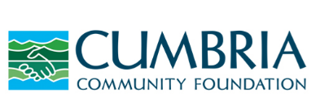
Cumbria Community Foundation are delighted to invite you to
An Evening with John James
Thursday 16 November, 6:15 - 8:30pm
at Ilona Rose House, London
kindly hosted by John James and Soho Estates
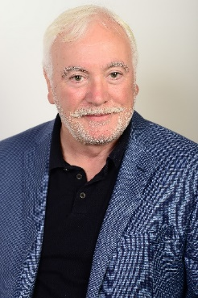
Please join us for drinks and canapes at the impressive Ilona Rose House, the newly built Soho Estates headquarters, with wonderful views of central London. The evening will also be an opportunity to hear John’s fascinating story, from growing up in Whitehaven, attending Art College in Carlisle and in the late 70’s heading south to make a life in London. He is now Managing Director of Soho Estates, the business developed by his late father-in-law, Paul Raymond, which owns large parts of Soho. You can find more about their history by clicking here.
Interviewing John will be Charlie Burgess, journalist and former Managing Editor of The Independent. Charlie has close ties with Cumbria and is a long-time supporter of Cumbria Community Foundation.
If you would like to join us for this special evening, please register using the following link Registration. As previous London events have proved popular, and places are limited, we would recommend reserving your place as soon as possible.
If you would like any further information about this event, or would like assistance with registration please contact Jackie Blacklock, email: jackie@cumbriafoundation.org or telephone: 01900 512392
We hope you will be able to join us.
Best wishes
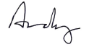
Andrew Beeforth OBE (He/Him)
Chief Executive
Cumbria Community Foundation

